Board of Directors

Teresa Enriquez
President

Juanita Walker
Vice President

Marie-Jo Toussaint
Secretary

Christopher Rose
Treasurer

Daniel Alfonso
Rosalind Castle
Rodolfo Llanes
Hemant Patel

Advisory Member

Trina Robinson/NBC 6

Founding Members

Carol McCracken
Marzell Smith

Advisory Board

Dori Alvarez
Rona Brandell
Jaquelyn Calzadilla
Priscila Eidam
Jacqueline Gonzalez-Cuba
Commissioner Wifredo Gort
Commissioner Keon Hardemon
Donald March, Jr.
Ian Moffett
Loren Parra
Commissioner Ken Russell
Akua Scott
Commissioner Francis Suarez

Selection Committee

Cristina De Varona
Sergio Guerrero
Kenia Fallat
Richard Perez
Aileen Rodriguez

Staff

Jodi Atkison
Executive Director

Ariadna Espinosa
Program Coordinator

August 2016

Dear Do The Right Thing Coordinator:

Welcome back! We hope you had a wonderful, restful summer. Please read this letter carefully.

The Do The Right Thing Program (DTRT), sponsored by the Miami Police Department, recognizes and rewards children for “doing the right thing.” Each month, as many as 700 children from Miami-Dade County are nominated by teachers, counselors, parents, police officers, and the public for the Do The Right Thing Award on the basis of their exemplary behavior and attitude. Ten monthly finalists are named and receive plaques and other prizes at a ceremony at the Miami Police Department with the Chief of Police. An overall monthly “Special Recognition” winner in middle or high school receives a trip to Washington, D.C. with other DTRT Special Recognition winners. An overall monthly “Special Recognition” winner in elementary school receives a trip to Rapids Water Park for four. All Top 10 winners are also featured on the DTRT website at www.dotherightthinginc.org . In order to reach as many children as possible and reinforce their positive behavior, ALL STUDENTS NOMINATED receive a certificate and a congratulatory letter from the City of Miami and Miami-Dade Schools chiefs of police, a free pizza from Papa John’s, a bumper sticker, and a Do The Right Thing T-shirt through School Mail.

STEP 1: REGISTER AS COORDINATOR
Log on to our website www.dotherightthinginc.org and fill out the DTRT Coordinator Registration Form found by clicking on the “Register (Schools Only)” button on the homepage. ALL COORDINATORS MUST REGISTER EVERY SCHOOL YEAR EVEN IF YOU’VE REGISTERED WITH US IN PREVIOUS YEARS.

STEP 2: PROMOTE WITHIN YOUR SCHOOL
All materials needed to promote the program throughout your school (principal and teachers) are available on our website under the Awards Program/School Info tab. Please print, copy, or email and distribute as necessary to all school personnel. At the beginning of the school year, we will be mailing program information along with our 2016-2017 Do The Right Thing calendar/poster in BROWN TUBES to the attention of Principal/DTRT Coordinator. Please check with your principal to obtain these materials. A poster will also be mailed to your attention once you sign up via the Coordinator Registration Form on our website.

STEP 3: NOMINATE
You MUST use our online nomination process by logging onto our website, clicking on the “Nominate Today” button on the homepage and following the directions accordingly. Nominations are required to be a minimum of 4 sentences.

STEP 4: TRACK YOUR NOMINATIONS
EACH SCHOOL IS LIMITED TO 15 NOMINATIONS PER MONTH AND NOMINATIONS ARE DUE BY THE 20th.

STEP 5: STAY CONNECTED
Please log on our website www.dotherightthinginc.org and periodically check the “Latest News” and “Coordinator Corner” sections of the homepage for all updates. You can also join us on Facebook by searching for “Do The Right Thing of Miami, Inc.,” and follow us on Instagram and Twitter by searching for @dtrtmiami.

If your school has a Top 10 winner, you will be notified by email. Additionally, your school should receive the prizes for the remaining nominees by the 20th of the following month through School Mail (PLEASE BE PATIENT AS THEY USUALLY TAKE ABOUT 2 WEEKS FOR DELIVERY). For example, October nominees will receive their prizes on or before November 20th.

If you have any questions, would like further information, or want to share your ideas about the program, please feel free to call 305-603-6957 or e-mail us at dtrtmiami@aol.com. Keep up the good work and we look forward to reading about your great kids this school year!

Sincerely,

Jodi Atkison

Jodi Atkison
Executive Director
Do The Right Thing of Miami, Inc.
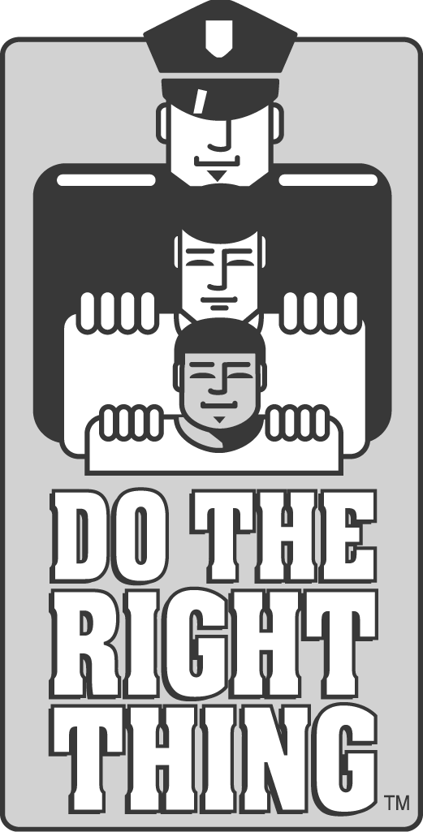
A not-for-profit organization dedicated to recognizing and rewarding our youth
DO THE RIGHT THING OF MIAMI, INC.
c/o City of Miami Police Department
400 N.W. 2ND Avenue / Room 201-J / Miami, FL 33128
Phone:305-603-6957/Website:www.dotherightthinginc.org
Twitter/Instagram: @dtrtmiami

