DO THE RIGHT THING OF MIAMI, INC.
c/o City of Miami Police Department
400 N.W. 2ND Avenue / Room 201-J / Miami, FL 33128
Phone: 305-579-3344/fax: 305-350-7919/www.dotherightthinginc.org

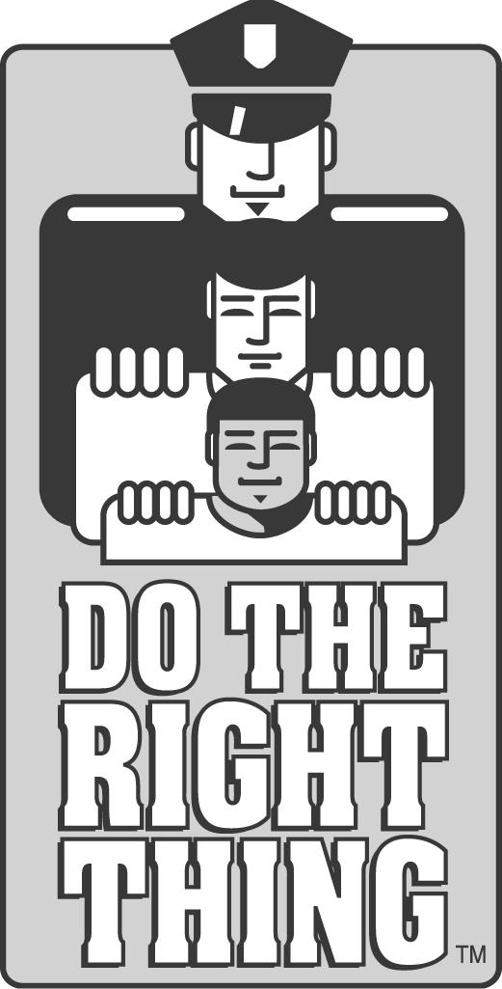

September 2011

Dear Do The Right Thing Coordinator/Principal:

The Do The Right Thing Program would like to invite you to participate in our annual “RAP IT UP!” Contest. The contest is being offered to all Miami-Dade County 3rd – 5th grade elementary school students and 6th – 8th grade middle school students.

The first place winners (one elementary school winner, one middle school winner) will each win an iPod nano and a trophy. First place winners’ schools will each receive $250 to be used for a pizza party in honor of the winner. The second place winners (one elementary school winner, one middle school winner) will each win a $75 Best Buy gift card and a trophy. The contest will run from October 1 – October 31, 2011. Any 3rd – 5th grade or 6th – 8th grade students with satisfactory grades and attendance may enter.

Attached is a colorful flyer for you to print out (black and white works too!) to use to promote the contest throughout your school. We will also be sending a larger, poster-sized version along with the DTRT calendar of events mailing (LOOK FOR BROWN TUBES) by the end of the month but wanted to give you time to begin planning the contest. I have also enclosed a “Contest Rules” sheet to be distributed to all entrants. We are allowing 50 entries per school. Please make sure that you or another staff person at your school coordinates the contest. There is a space on the flyer for the contact person to put his/her name and room number, informing the students of where to get additional information and where to drop off their entries.

I would appreciate if you or the contest coordinator would email us at dtrtmiami@aol.com to let us know who will be coordinating it. It is imperative that we know if you are participating in case we must send out additional information to the contact people.
Contest coordinators are responsible for promoting the contest, distributing “Contest Rules” sheets (make copies as necessary) and submitting rap entries. Entries must be received by the Do The Right Thing office no later than MONDAY, NOVEMBER 7, 2011. ONLY 50 RAPS PER SCHOOL PLEASE! PLEASE REVIEW ALL ENTRIES FOR INAPPROPRIATE LANGUAGE AND/OR CONTENT PRIOR TO SUBMISSION. Entries may be sent by school mail to: Do The Right Thing Contest, Mail Code 9999 or they may be posted or dropped off to: Do The Right Thing, c/o Miami Police Department, 400 N.W. 2nd Avenue, Room 201-J, Miami, FL 33128.

Approximately 20 elementary school participants and 20 middle school participants will be selected to audition their raps at the Miami Police Department in front of a panel of judges in early December. Based on their audition performance, the top 5-10 elementary and top 5-10 middle school students will be invited to the final competition in mid-December. The first and second place winners and semifinalists will be announced at that time.

Thank you for your cooperation with this project. Good luck!

Sincerely,

Jodi Atkison

Jodi Atkison
Executive Director
Do The Right Thing of Miami, Inc.

Enclosures
A not-for-profit organization dedicated to recognizing and rewarding our youth

